Rhea Nayyar

nayyar.rhea18@gmail.com

Faculty of Social Science,

Dayalbagh Educational Institute

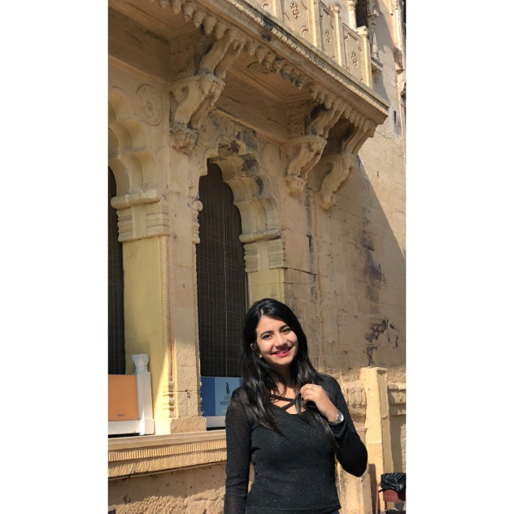You can do anything as long as you have the passion, thedrive, the focus, and the support. From my childhood days my parents have always encouraged me to do what I love and pursue my passion. I started learning skating at the age of 7, and through all the ups and downs, crying and laughing I went on to finally represent my school at many tournaments and finally at district level. My friends also call me a water baby and that is quite justified by the fact that at times I was not skating or studying I used to be swimming. I am right now 21 and pursuing master’s in business administration, which is a rigorous and professional course, but I have always used my creativity and artistic nature in making the presentations.

My college has brought out a great orator from me, as I took part in many elocution competitions in my college and creative learning competitions like CRAZY IDEAS.

I also participated in western singing and sang some of my favourite songs. But my passion still stands for fashion, I can proudly call myself a fashion enthusiast, I follow all the latest fashion bloggers, the latest trends and the ongoing fashion weeks. I really hope and wish to do a fashion management course in the near future!